Brian Engel

Module 5 Encryption Activity

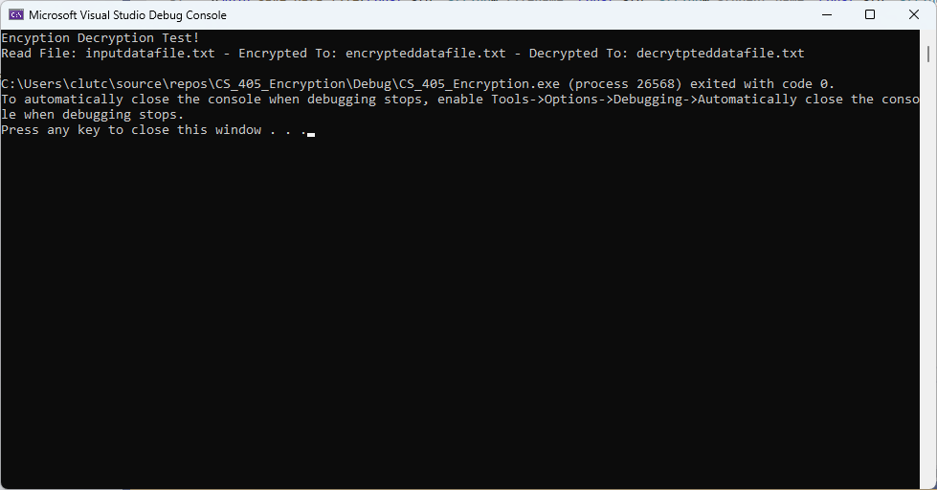

To enable the encrypt_decrypt function all that we needed to do was add the XOR to the source string. To be honest I haven’t had to read or write a file in a while, so that took a little more effort but came back to me pretty quickly. For the read_file function I opened the file and added some error checking to make sure it was open. Then I used stringstream to read the file into a buffer, and then converted the buffer into a string, then closed the file. In the save_data_file function I opened the file with error checking, wrote student name, timestamp, key and data to the file with labels. I ended up using ctime_s for the timestamp, which uses a char array which I was worried about because of overflow, but the size is always less than 26 so I used that for the size. I also added some print statements for error checking and commented them out.